RESPONSE TO THE BIODIVERSITY DUTY
April 2026

Version ID | Description of Change | Version  Sponsor | Policy Owner | Version  creation  date | Version  Approval  Date | Next  Review  Date
1.0 | Drafted by Parish Clerk | Parish Clerk | Full Council | Nov 2023 | Dec 2023 | Dec 2026
1.1 | Updated by Parish Council | Parish Clerk | Full Council | 07.04.26 | May 2026 | Dec 2026

Introduction - Statutory Duty

Under the 2021 Environment Act, public authorities (including town and parish councils) who operate in England must consider what they can do to conserve and enhance biodiversity in England.

Government guidance published on 17th May 2023 clarifies that, as a public authority, town and parish councils must:

- Consider what they can do to conserve and enhance biodiversity.
- Agree policies and specific objectives based on their consideration.
- Act to deliver their policies and achieve their objectives.

Town and parish councils, unlike other authorities, are not obliged to publish a report on their actions, but the Government guidance requires all public authorities to complete their first consideration of what action to take for biodiversity by 1 January 2024. They must agree their policies and objectives as soon as possible after this and may reconsider the selected actions within 5 years of completing their previous consideration, or more frequently if they choose.

To comply with the guidance, town and parish councils could as a minimum:

- Have biodiversity as an agenda item for a meeting before the end of 2023.
- Note what action in respect of biodiversity is already taking place locally.
- Agree what further steps to take at this stage.

Such steps may include:

- Reviewing what biodiversity or nature recovery plans are already in place from other local authorities.
- Making contact with local voluntary groups working on nature conservation.
- Carrying out a biodiversity audit of council landholdings and/or the whole council area
- Gathering expert advice on possible actions in support of biodiversity.
- Drafting an action plan that covers action that the council will take itself as well as support for the actions of other local bodies.

Whatever action is agreed, as a minimum local councils could ensure they address biodiversity concerns when commenting on planning applications.

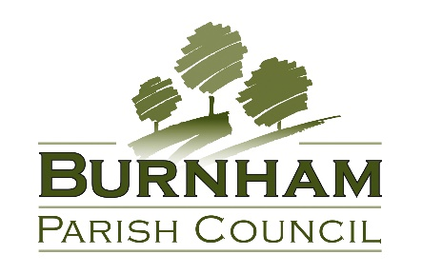

BIODIVERSITY POLICY

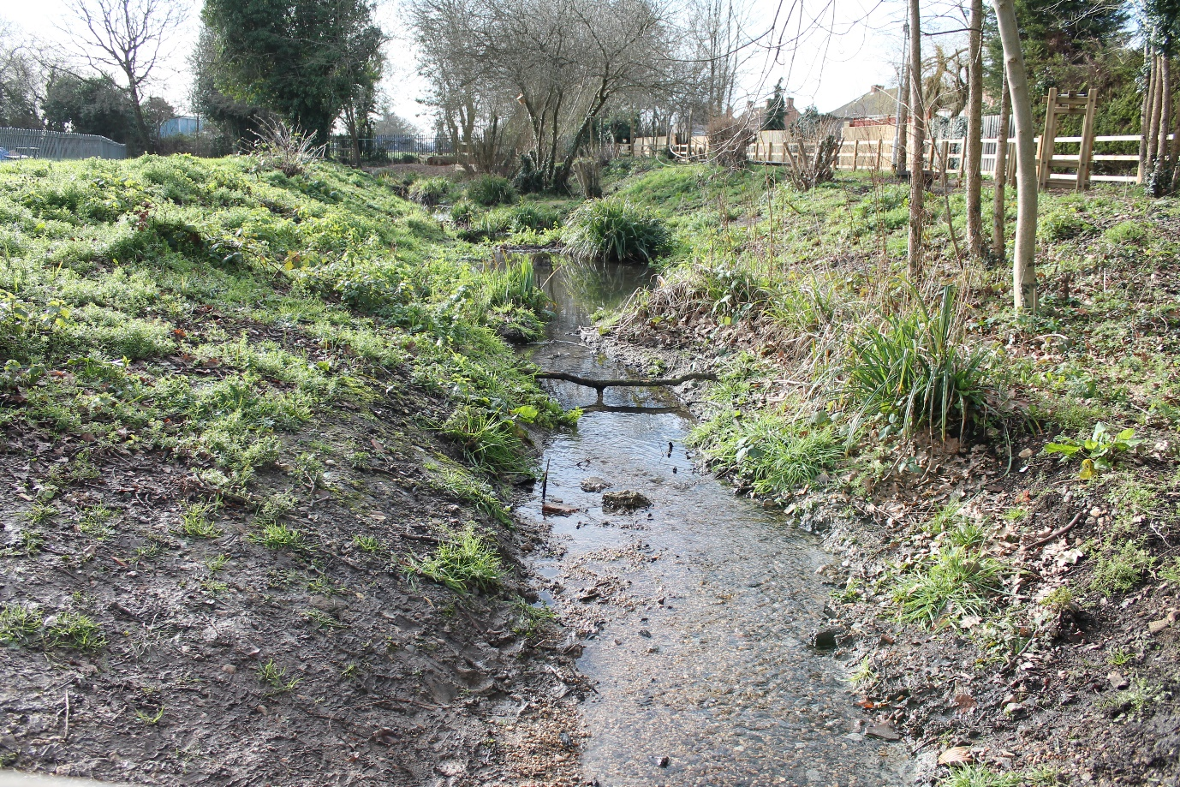

INTRODUCTION

In accordance with the duty imposed on town and parish councils by Section 40 of the Natural Environment and Rural Communities Act 2006, updated by Section 102 of the Environment Act 2021, Burnham Parish Council will in exercising all its functions have regard to the purpose of conserving biodiversity.

This duty also means that town and parish councils can spend funds in conserving biodiversity.

DEFINITION

According to Defra (Biodiversity 2020), biodiversity is the variety of all life on Earth. It includes all species of animals and plants – everything that is alive on our planet.

Biodiversity is important for its own sake and has its own intrinsic value. A number of studies have shown this value also goes further. It is the building block of our ‘ecosystems’. These provide us with a wide range of goods and services that support our economic and social wellbeing. These include essentials such as food, fresh water and clean air, but also less obvious services such as protection from natural disasters, regulation of our climate, and purification of our water or pollination of our crops. Biodiversity also provides important cultural services, enriching our lives.

AIMS AND OBJECTIVES

The object of this policy is to work towards enhancing and protecting the biodiversity of Burnham.

All committees of Burnham Parish council will consider sustainability, environmental impact and biodiversity when making decisions and will develop and implement policies and strategies as required.

In particular, Burnham Parish council will aim to improve the biodiversity of the area in the following ways:

- consider the potential impact on biodiversity represented by planning applications.
- manage its land and property using environmentally friendly practices that will promote biodiversity.
- support local businesses & council operations in the adoption of low impact practices.
- support residents and local organisation activities to enhance and promote biodiversity.

ACTIONS

Planning applications

- The council, when commenting on planning applications, will support site and building design that benefits biodiversity through the conservation and integration of existing habitats or provision of new habitats.
- It will support protection of sensitive habitats from development and will consider whether the development would mean the loss of important habitats for wildlife in respect of all applications.
- It will consider what each proposed development might make in terms of biodiversity net gain.
- It will include policies in support of biodiversity within the neighbourhood plan.

Land and property management

- The council will carry out a biodiversity audit of its landholdings.
- The council will consider the conservation and promotion of local biodiversity with regard to the management of its open spaces. This will include adopting beneficial practices with regarding to cutting and removal of vegetation, application of chemicals and timing of maintenance work.
- Special care will be taken in the specification of grounds maintenance contracts to ensure that the work, whilst reaching acceptable standards, does not harm the natural environment.
- The council will consider biodiversity issues and the implementation of changes when managing its buildings.

Local community

- The council will raise public awareness of biodiversity issues, including through its website and social media.
- The council will engage with local businesses and residents regarding biodiversity in the community and how members of the community can assist and make a difference.
- It will, where feasible, involve the community in biodiversity projects on its land including for example tree planting, wildflower meadows, birdbox making.

Partners

- Burnham Parish Council will work in partnership with other organisations to protect, promote and enhance biodiversity within areas of the Parish.
- It will review any local nature recovery strategies, species conservation strategies, or protected site strategies in respect of local sites of special scientific interest (SSSIs) and consider how it may become more involved in implementing the strategies’ recommendations.

ACTION PLAN

SITE / OBJECTIVE | ACTION | OUTCOME | TARGET  (Years) | REPORTING / PUBLICITY
Whole council area  Protect and support  biodiversity | Raise local awareness of biodiversity.  Encourage suitable planting to support biodiversity. | Gain local support for action.  Connect & diversify habitats to meet the needs of a variety of  wildlife species | Ongoing  Ongoing | Website/Social Media  Mapping
Cemetery / churchyard | Additional planting  Maintain and renew bird/bat boxes as required.  Adopt a plan to support wildlife & diversity whilst maintaining the site in a way which enables visitors to experience quiet and calm remembrance. | Increased diversity of habitats and food sources  Increased cover for invertebrates, reptiles, amphibians and small mammals.  Encouraging insects particularly butterflies & bees. | Ongoing | Website/Social Media
Parks and open spaces | Sympathetically maintain hedging.  Leave some areas unmown.  Only use environment friendly pesticides where absolutely necessary and only in ideal weather conditions.  Encourage residents to remove litter and pick up after their dogs. | Food sources & cover  Encourages insects.  Sustain & enhance  natural habitats. | Ongoing | Website/Social Media
The Built  Landscape | Ensure that planning consultations are considered against the requirements of the Neighbourhood Plan once ‘made’  Encourage hedgehog/small animal highways with  permeable boundaries | Protecting/enhancing  habitats  Extending habitats. | Ongoing | Website/Social Media
SITE / OBJECTIVE | ACTION | OUTCOME | TARGET  (Years) | REPORTING / PUBLICITY
Increase  community awareness of biodiversity | Ask residents for their views on what they would like to be done to conserve biodiversity within the parish.  Raise awareness of the importance of gardens as  habitats for wildlife, with possible actions highlighted in the to residents  Create a page on the parish council website for  photographs / information / links  Encourage local farmers to contribute.  Provide seed bombs / bulbs etc. for residents’ use.  Discourage floodlighting. | Engagement/ownership of biodiversity  Promote biodiversity.  Promote biodiversity.  Promote biodiversity.  Extending habitats.  Protect nocturnal animals. | Ongoing | Website/Social Media
Support  Community  Projects | Support hedge/tree planting in any appropriate areas.  Work in partnership with the school to develop young people’s awareness of the environment around them.  Consider events and offer volunteering opportunities to support biodiversity, working with local organisations. | Extending habitats.  Promote biodiversity.  Promote biodiversity. | Ongoing | Website/Social Media

