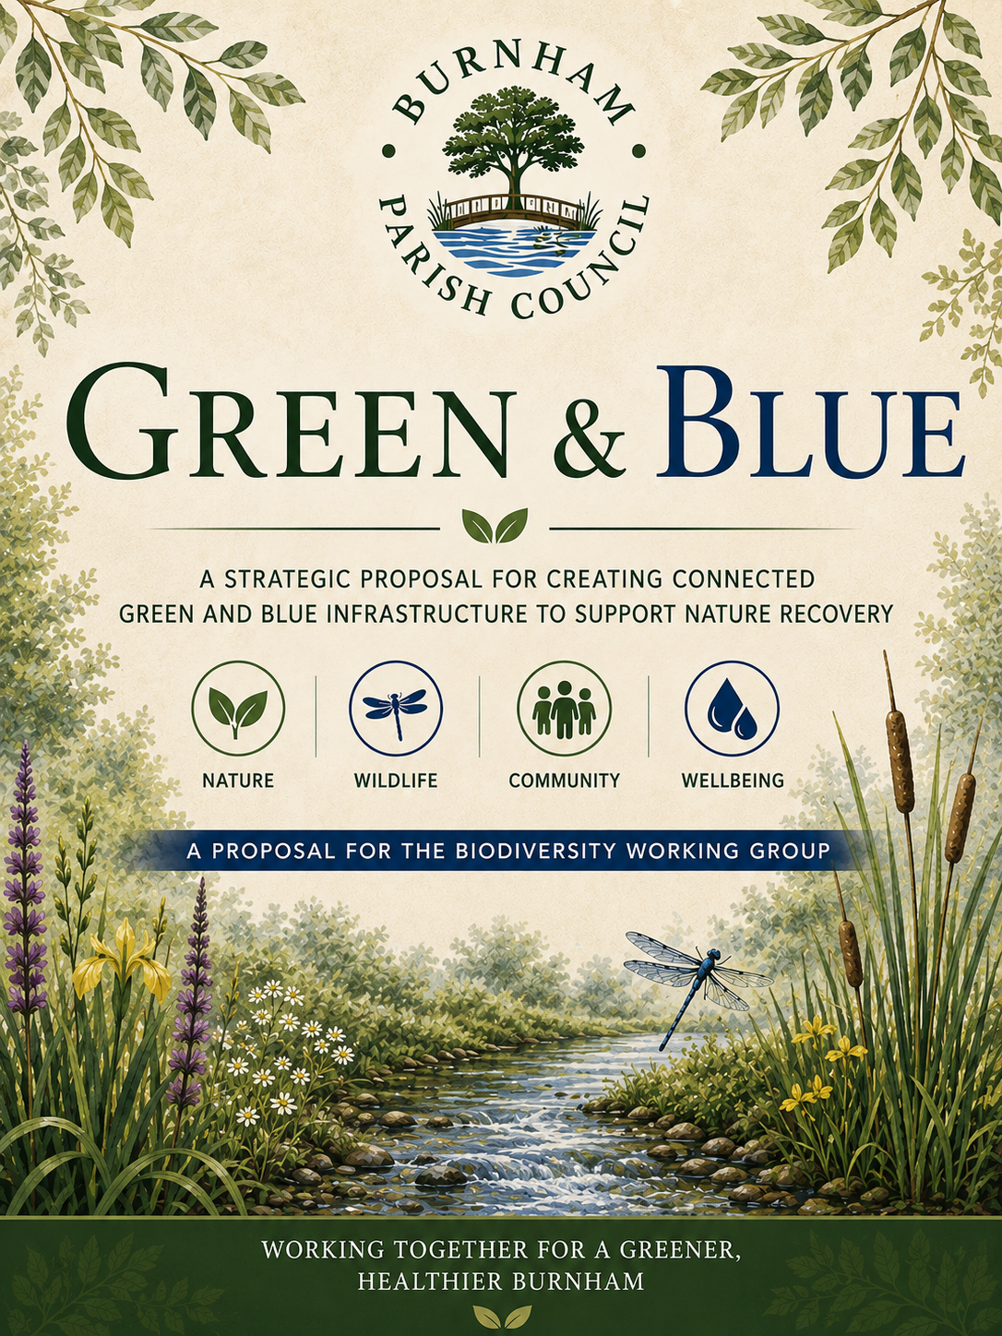

Green & Blue
Burnham Green & Blue Nature Recovery Strategy (2027–2032)

Written by Cllr Paul Bunce, Approved by Full Council, 5th October 2026

Five-Year Strategy with Stage 1 Delivery Programme for Connected Green and Blue Infrastructure
Prepared for:
R&A committee
Playgrounds Working Group
Ecological, Biodiversity & Sustainability Working Group
The Pond Working Group
Deputy Clerk / Cllr Carey, working on The Burn

Executive Summary

The United Kingdom has experienced significant declines in biodiversity over recent decades. Native pollinators, butterflies, dragonflies and many other invertebrates have suffered habitat fragmentation, reduced food availability, pollution, invasive species and climate change. Local authorities have an increasingly important role in reversing these trends through thoughtful management of public spaces.
The "Green & Blue" initiative is a five-year Burnham Parish nature-recovery strategy. Stage 1 is the immediate delivery programme and focuses specifically on The Burn, The Pond and the Living Corridor that links them, supported by education, community engagement and clear project management. Later phases can build on this foundation across St Peter's Recreation Ground, Burnham Park and other suitable Council-managed green spaces. By improving both terrestrial ("Green") and aquatic ("Blue") habitats using native plant species and wildlife-friendly management practices, the Council can increase biodiversity while enhancing the quality of public open spaces.

The strategy recognises that isolated habitats rarely provide sufficient ecological resilience. Instead, wildlife requires connected landscapes that allow species to move, breed, forage and adapt to environmental change.

This proposal aligns with national legislation including:
Environment Act 2021
Biodiversity Net Gain (BNG)
Local Nature Recovery Strategies (LNRS)
Pollinator Strategy for England
25 Year Environment Plan
Climate Change Adaptation Strategy
Local Plan environmental policies

The project represents a long-term investment in natural capital, delivering environmental, social and economic benefits. It is not intended to restrict the Council or to prevent it from adapting to changing circumstances. It is also not expected that the Council will be able to implement every aspect of the report at all times – it is a framework for responding to the current crisis and a guide for possible action.

Stage 1 – 2027 Delivery Programme
Stage 1 is the first year of the adopted five-year Green & Blue programme. It is also the defined scope for the initial funding application. The purpose of Stage 1 is to create a visible, practical and educational connection between The Burn and The Pond, rather than attempting to deliver the whole five-year strategy at once.

Stage 1 priorities
The Burn: Clear and improve the stream with expert support from specialist contractors and, where appropriate, community volunteers; reseed and establish wildflowers between The Burn and St Peter's; install an interpretation board; provide pond-dipping kits for public or supervised educational use; and restore the wooden pathway/bridge feature. A small dipping platform and additional planting remain possible additions subject to ecological, access, safety and cost advice.
The Living Corridor: Create a clearer route between The Burn and The Pond using coordinated signage that reflects the movement of water through Burnham. Use the proposed Green & Blue mosaic as a visual marker and focal point to draw people along the corridor in both directions.
The Pond: Introduce appropriate wildflower and pond planting, alongside bird, bat and invertebrate habitat features where suitable. Works should be informed by site conditions and ecological advice so that biodiversity enhancement and the public appearance of the pond are balanced.
Education and engagement: Produce Green & Blue leaflets and activities for young people, using The Burn, The Pond and the connecting corridor as living classrooms. Interpretation should explain how the sites connect through water, habitat and wildlife movement.
Management: Use a project steering group comprising councillors, staff and key partners for strategic oversight; the Clerk or Deputy Clerk for operational coordination; and the Grounds Team for day-to-day space management, supported by specialist contractors and volunteers where appropriate.

Funding boundary
Any Stage 1 grant application should cost and describe only the first-year works above. The wider five-year proposals in this document provide the strategic context and future direction; they should not be presented as commitments to be delivered from the Stage 1 funding award unless separately approved and funded.
Why "Green & Blue"?
Historically, green spaces and watercourses have often been managed separately. Yet nature does not recognise administrative boundaries. Many species depend upon both terrestrial and aquatic habitats throughout their life cycles.

For example:
Dragonflies lay eggs in water but spend much of their adult life hunting over grassland.
Frogs require ponds for breeding but woodland and long grass for shelter.
Butterflies require nectar-rich flowers but also sheltered hedgerows.
Pollinating insects move continuously between trees, meadows and waterways.
Connecting these habitats creates ecological corridors rather than isolated pockets of biodiversity.
Strategic Vision
To establish a parish-wide network of connected green and blue infrastructure that supports thriving populations of native wildlife while enhancing the landscape for residents and visitors.
Burnham Green & Blue Network – Delivery Sequence
- Stage 1: The Pond – Aquatic Biodiversity Hub
- Stage 1: The Living Corridor – Ecological Connection
- Stage 1: The Burn – Riparian Habitat
- Future phase: St Peter's Recreation Ground – Community Nature Park
- Future phase: Burnham Park – Woodland & Open Landscape

Understanding the Biodiversity Crisis

Current evidence indicates that:
Over 40% of UK insect species are experiencing long-term decline.
Nearly 80% of butterfly species have declined in abundance or distribution.
Freshwater habitats remain among the most threatened ecosystems.
Habitat fragmentation is one of the greatest barriers to species recovery.

Many Council-owned spaces already have considerable ecological potential and are currently managed with an emphasis on appearance; however, there is an opportunity to adopt a more balanced approach that enhances biodiversity while maintaining attractive and well-kept public spaces. Simple changes in management can produce significant additional ecological gains.

Strategic Objectives
- Increase Biodiversity
1.1 Support the creation of additional diverse habitats that support a wide range of species including insects, birds, mammals, amphibians and aquatic life.
1.2 Introduce a variety of native plants that provide year-round food sources such as nectar, pollen, seeds and berries; at an appropriate cautious pace and guided by expert advice.
1.3 Support the enhancement of structural diversity within landscapes by incorporating trees, shrubs, wildflowers, long grass and wetland features.
1.4 Support breeding, nesting and overwintering opportunities for wildlife across different habitat types.
- Improve Ecological Connectivity
2.1 Support the reduction of habitat fragmentation by linking parks, green spaces, waterways and roadside verges into continuous wildlife corridors.
2.2 Support projects that enable species to move safely between habitats for feeding, breeding and seasonal migration.
2.3 Encourage developers to Integrate green and blue infrastructure into urban planning to create a cohesive ecological network.
2.4 Work to help strengthen resilience of wildlife populations by reducing isolation and increasing genetic diversity.
- Restore Native Plant Communities on Council land
3.1 Replace ornamental or low-value planting with native species that are better suited to local conditions and wildlife needs.
3.2 Re-establish traditional plant communities such as meadows, hedgerows and wetland vegetation.
3.3 Prioritise species that have strong ecological relationships with native insects and pollinators.
3.4 Reduce reliance on non-native species that offer limited ecological benefit.

- Improve Water Quality
4.1 Increase aquatic and marginal vegetation to naturally filter pollutants and sediments from water bodies.
4.2 Use appropriate plants to absorb excess nutrients and improve oxygen levels in ponds, streams and rivers.
4.3 Incorporate sustainable drainage systems (SuDS) such as rain gardens and swales to manage runoff on council land where appropriate and feasible; and encourage such provision in proposals for development in Burnham.
4.4 Enhance the ecological health of aquatic environments on council land, supporting fish, amphibians and invertebrates where appropriate to the specific environment.
- Increase Climate Resilience
5.1 Use vegetation to reduce flood risk through natural water absorption and storage.
5.2 Provide shading and cooling in urban areas to mitigate the urban heat island effect.
5.3 Improve soil structure and moisture retention through increased plant cover.
5.4 Support ecosystems that are better able to adapt to changing climate conditions.
- Engage Communities
6.1 Develop volunteer programmes that involve residents in planting, maintenance and monitoring activities.
6.2 Encourage citizen science initiatives such as butterfly counts, pollinator surveys and water quality monitoring.
6.3 Further engagement with schools and community groups to deliver educational projects and outdoor learning opportunities.
6.4 Foster an increased sense of ownership and stewardship of local green and blue spaces.
- Reduce Long-Term Maintenance Costs
7.1 Introduce additional sustainable management practices such as reduced mowing and naturalised planting schemes.
7.2 Decrease labour and operational costs through less intensive maintenance regimes where appropriate.
7.3 Help to create self-sustaining habitats that require minimal intervention once established.

The Importance of Native Plants

Native plants have evolved alongside native insects over thousands of years.
Many insects cannot utilise imported ornamental species.
For example:
Oak trees support over 2,000 associated wildlife species, including caterpillars of moths such as the Winter Moth and Oak Beauty, beetles like the Stag Beetle, and birds such as Blue Tits and Great Spotted Woodpeckers that feed on the abundant insect life.
Hawthorn supports hundreds of insects, including aphids, shield bugs and caterpillars of species such as the Hawthorn Moth, while its berries provide food for birds like Thrushes and Blackbirds in autumn.
Blackthorn provides early nectar for emerging pollinators such as bumblebees and solitary bees, and also serves as a larval food plant for butterflies like the Brown Hairstreak and moths such as the Blackthorn Moth.
Bird's-foot Trefoil is essential for several butterfly species, including the Common Blue, Dingy Skipper and Six-spot Burnet moth, whose caterpillars rely on it as a primary food source, while its flowers attract a wide range of bees and other pollinating insects.
Increasing native planting directly increases food availability for wildlife

Blue Infrastructure
Pond
Note: this guidance applies to ponds in general, and as noted some of it is not currently relevant to the Council owned pond, but may be relevant to future ponds – for example on future developments within the parish, or any other ponds that the council takes on or creates.
Where possible, ponds should contain a variety of planting zones.
- Deep water (note: probably not appropriate for current Council owned pond)
- Provides refuge for fish and aquatic invertebrates during extreme temperatures and drought conditions
- Supports submerged and oxygenating plants that improve water quality
- Helps maintain stable water levels within ponds and wetlands
- Creates habitat for species that require deeper, cooler water environments
- Floating vegetation
- Offers shade, helping to regulate water temperature and reduce algal blooms
- Provides resting and feeding platforms for insects such as dragonflies and damselflies
- Protects aquatic life from predators by creating cover
- Contributes to improved water quality by absorbing excess nutrients
- Marginal vegetation
- Serves as critical breeding and egg-laying habitat for amphibians and dragonflies
- Stabilises pond edges and reduces erosion
- Provides nectar sources for pollinators including bees and butterflies
- Acts as a transition zone between aquatic and terrestrial habitats, increasing biodiversity
- Wet meadow (note: needs further consideration for current Council owned pond)
- Supports a wide range of wildflowers that provide nectar throughout the growing season
- Offers habitat for insects, small mammals and ground-nesting birds
- Helps absorb excess water, reducing flood risk
- Enhances visual appeal with seasonal colour and diversity
This creates habitat for every life stage of aquatic insects.

Recommended Aquatic Plants
Marginal
- Marginal Plants
Marginal plants grow at the edges of ponds, streams and wetlands where water levels fluctuate. They play a crucial role in stabilising banks, reducing erosion and filtering pollutants from surface runoff before they enter the water. Suitable professional advice would be sort to ensure the correct plants for local use in the Council’s own pond(s). These plants provide essential habitat for insects, amphibians and birds, offering shelter, breeding sites and nectar sources. Their flowers are particularly valuable for pollinators such as bees, butterflies and hoverflies, while their stems and leaves create ideal egg-laying sites for dragonflies and damselflies.
- Marsh Marigold
- Water Mint
- Yellow Flag Iris
- Purple Loosestrife
- Brooklime

Suitable professional advice will be taken on the best plants for local use in the Council’s own pond(s).

- Floating Plants
Floating plants sit on the surface of the water and help regulate light penetration and temperature within aquatic environments. By providing shade, they reduce excessive algae growth and help maintain water quality. Their leaves offer resting platforms for insects such as dragonflies, while their roots provide shelter for fish and aquatic invertebrates. These plants also contribute to oxygen balance and create a more stable and resilient aquatic ecosystem.
- Frogbit
- White Water Lily
- Yellow Water Lily

- Oxygenating Plants
Oxygenating plants grow beneath the water surface and are vital for maintaining healthy aquatic ecosystems. They release oxygen into the water during photosynthesis, supporting fish, amphibians and invertebrates. These plants also absorb excess nutrients, helping to prevent algal blooms and improve water clarity. Their dense underwater structure provides refuge for larvae, including dragonfly nymphs, and supports a diverse range of aquatic life at different stages of development.
- Hornwort
- Water Crowfoot
- Water Starwort

Endangered species and what they need

The programme should focus on creating habitats capable of supporting a wide range of native wildlife, grouped by their primary habitat requirements. Further communications with trained professionals and experts would need to take place to ensure the successful integration and survival of any suitable species reintroduced on to appropriate Council owned properties.

Terrestrial Species
Pollinators
- Shrill Carder Bee – requires flower-rich grasslands with clover and undisturbed nesting areas.
- Brown-banded Carder Bee – needs wildflower meadows with abundant nectar sources and long grass for nesting.
- Solitary Bees – depend on bare soil or hollow stems for nesting and a variety of flowering plants.
- Mining Bees – require sandy or loose soil for burrowing and early spring flowers for food.
- Hoverflies – need nectar-rich flowers for adults and aphid populations for larvae.
Butterflies and Moths
- Small Blue – relies on Kidney Vetch plants for egg-laying and sunny, sheltered grasslands.
- Grizzled Skipper – needs sparse grassland with wild strawberries and bare ground.
- Common Blue – depends on Bird’s-foot Trefoil and open grassy habitats.
- White-letter Hairstreak – requires elm trees for breeding and nearby nectar sources.
- Heath Fritillary (where suitable habitat can be established) – needs coppiced woodland with abundant cow-wheat.
Beetles
- Stag Beetle – requires decaying wood for larvae and undisturbed habitats.
- Violet Ground Beetles – need damp soil and leaf litter for shelter and hunting.
- Ladybirds – depend on aphid populations and flowering plants.
- Soldier Beetles – require flowers for feeding and grassy areas for larvae.
Arachnids
- Wasp Spider – needs tall grassland with good insect populations.
- Wolf Spiders – require open ground and leaf litter for hunting.
- Orb-weavers – depend on vegetation structures to build webs and abundant flying insects.
- Jumping Spiders – need sunny areas with varied surfaces for hunting prey.
Reptiles
- Common Lizard – requires sunny basking spots, rough grassland and shelter.
- Slow Worm – needs compost heaps, dense vegetation and undisturbed ground.
- Adder (where appropriate habitat exists nearby) – requires heathland or rough grassland with basking areas and cover.

Aquatic Species
Dragonflies and Damselflies
- Southern Hawker – needs clean ponds with vegetation for egg-laying.
- Emperor Dragonfly – requires large, well-vegetated water bodies.
- Broad-bodied Chaser – depends on shallow ponds with sunny margins.
- Azure Damselfly – needs still or slow-moving water with aquatic plants.
- Common Blue Damselfly – requires clean water and emergent vegetation.

Species Using Both Terrestrial and Aquatic Habitats
Amphibians
- Great Crested Newt – needs clean ponds for breeding and rough grassland or woodland for shelter.
- Smooth Newt – requires small ponds and nearby vegetation for feeding.
- Common Frog – depends on garden ponds and damp habitats.
- Common Toad – needs larger ponds and terrestrial habitats such as woodland or hedgerows.
Semi-aquatic Reptiles and Arachnids
- Grass Snake – requires ponds for feeding and rough grassland for shelter and egg-laying.
- Nursery Web Spider – needs damp vegetation near water to hunt and build nursery webs.

Sustainable Grounds Maintenance
To maximise biodiversity, the Council should consider adopting or increasing wildlife-friendly maintenance practices, including:

- Rotational grass cutting, whereby different sections of grassland are cut at different times of the year, ensuring that some areas are always left undisturbed to provide continuous habitat, shelter and food sources for insects, small mammals and ground-nesting species. This is already being done in some areas, and this will be kept under review.
- Increasing the length of mowing cut in selected areas, allowing grasses and wildflowers to grow more and complete their life cycles, which supports pollinators and increases plant diversity.
- Continuing to minimise pesticide use unless essential, and where intervention is necessary, prioritising targeted, environmentally sensitive methods to minimise harm to beneficial insects, soil organisms and aquatic life.
- Leaving cut overwintering vegetation including long grass, stems and leaf litter, in place to rot down and provide habitats to provide vital shelter for insects, spiders and amphibians during colder months, helping to sustain populations into the following spring.
- Continuing to leave areas of rough grass and unmanaged margins for reptiles and invertebrates, creating warm, sheltered microhabitats that are essential for basking, hunting and breeding. This is currently done in the park and pond, and the Council will consider any suggestions for additional areas, taking into account the uses of those areas.
- Protecting amphibian breeding ponds during spring by limiting maintenance activities nearby, avoiding disturbance to spawning areas, and ensuring that water quality and surrounding vegetation remain suitable for successful reproduction. At time of writing the Council’s pond had recently seen a return of some amphibian life to the pond, so this could become increasingly relevant.
These measures can reduce maintenance costs while significantly increasing habitat value.

Community Engagement
The success of this initiative will rely upon active community involvement. The level of such involvement that can be led directly by the Council will depend on Councillor and staff capacity, although the addition of the proposed new Community Project Officer role will assist with this. The Council will also look to support other organisations who are planning such activities.
Suggested activities include:
- Annual Biodiversity Week.
- Community meadow planting days.
- Wildlife recording projects.
- School pond dipping sessions.
- Pollinator surveys.
- Reptile and amphibian monitoring.
- Volunteer conservation groups.
- Educational interpretation boards.
- Partnerships with local schools, environmental organisations and residents' associations.
Community participation will strengthen local ownership and foster a lasting culture of environmental stewardship.

Monitoring and Evaluation
Where suitable volunteers or organisations are available, progress should be monitored annually through:
- Pollinator counts.
- Butterfly transects.
- Dragonfly surveys.
- Amphibian breeding surveys.
- Reptile refuge monitoring.
- Spider recording.
- Botanical surveys.
- Water quality assessments.
- Habitat condition reports.
- Volunteer participation statistics.
Monitoring will enable adaptive management and ensure continuous improvement.

Expected Outcomes
Within five years the programme should aim to deliver:
- A significant increase in pollinator populations.
- Improved populations of amphibians and reptiles.
- Enhanced ecological connectivity between Burnham's green spaces.
- Greater public awareness of local wildlife.
- Reduced long-term maintenance costs in selected areas.
- Improved water quality within ponds and streams.
- Increased community participation in environmental projects.
- Recognition of Burnham as a parish committed to nature recovery and sustainable land management.

Project Delivery and Long-Term Management
If and where there is a successful grant application, and no other projects of more importance are being carried out the majority of investment, labour and specialist ecological work will be concentrated during the first year of any programme.

This will help to reverse habitat degradation, improve ecological function and support the conditions necessary for long-term biodiversity recovery. Initial works may include ecological surveys, selective vegetation clearance, sediment assessments, water quality monitoring, habitat creation and, where supported by detailed design and the appropriate regulatory approvals, restoration of the stream and pond profiles. These activities represent the most resource-intensive phase of the programme.

As habitats become established and ecological processes recover, the level of intervention will reduce significantly. Years Two and Three will focus primarily on targeted habitat enhancement, planting and monitoring, while Years Four and Five will transition towards adaptive management, routine maintenance and community-led conservation activities. This phased approach is expected to reduce annual maintenance requirements over time, as healthy ecosystems become increasingly self-sustaining and natural processes assume a greater role in maintaining habitat quality. By the end of the five-year programme, management should consist largely of periodic monitoring, selective vegetation management, invasive species control where necessary and ongoing community engagement, providing a cost-effective and sustainable long-term model for managing Burnham's natural assets.

The above outline programme will be affected by success in achieving grants, staff and councillor capacity, and support from volunteers and other organisations.

Conclusion
Burnham has a unique opportunity to become a model for local nature recovery by protecting and enhancing the habitats that support some of Britain's most threatened wildlife. Through practical habitat restoration, sensitive land management and strong community involvement, the Parish Council can create an interconnected landscape where insects, arachnids, reptiles and amphibians flourish alongside vibrant, accessible public spaces.

This proposal is intended as the foundation of a long-term biodiversity programme that will deliver lasting environmental, social and economic benefits for Burnham and future generations. By investing in nature today, Burnham Parish Council can help secure a healthier, more resilient landscape that reflects the community's commitment to sustainability, conservation and civic pride.

