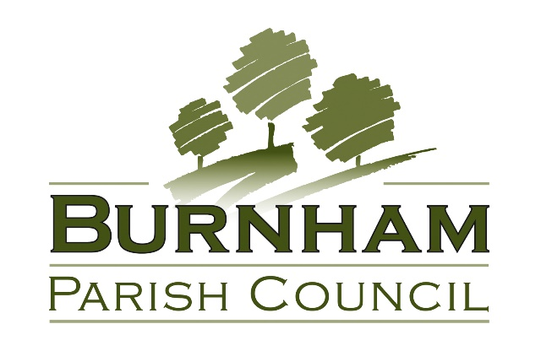

**Animal Welfare (events and activities) Policy**

**July 2025**

**TABLE OF CONTENTS**

1. INTRODUCTION AND OBJECTIVES…………………….…………………………………………………….2
2. APPLICATION AND INTERPRETATION OF POLICY…………………………………………………….2
3. LEGISLATION…………………………………………………………………………………….……………………2
4. COMMERCIAL ANIMALS……………………….…………..……………..…………………………………...2
5. DOMESTIC ANIMALS……………………………………………………………………………………………..3
6. LIVE ANIMALS AS PRIZES….…………………………………………………………………………………….3
7. DOCUMENT HISTORY…………………………………………………………………………………………….3
8. **INTRODUCTION**

The underlying purpose of this policy is to ensure the welfare of animals and appropriate management of associated risks at any events or activities associated with the Council; whilst allowing for animals at such events and activities where appropriate conditions are met. It reflects the growing public recognition of the importance of animal welfare, and well as the positive role that the appropriate involvement in animals in events and activities can have for both the animals and the public.

1. **APPLICATION AND INTERPRETATION OF POLICY**

The Clerk shall have overall responsibility for the application and interpretation of this policy. Where another officer is responsible for organising or liaising with an event, they shall follow the requirements of the policy and report any concerns to the Clerk.

This policy applies to any events or activities that meet one or more of the following conditions:

1. They are being organised solely or jointly by the Council.
2. They are taking place partly or wholly on Council land or premises.
3. They are being given grant support by the Council.

Where the above does not apply but the Council is considering publicising or otherwise supporting an event, the Clerk will have regard to this policy in considering whether such support is appropriate.

1. **LEGISLATION**

Relevant legislation includes the Animal Welfare Act 2006, the Animal Welfare (Licensing of Activities Involving Animals) (England) Regulations 2018, The Dangerous Wild Animals Act 1976 and the Zoo Licensing Act 1981.

Buckinghamshire Council has statutory responsibilities for the licensing of a number of activities relating to the welfare of animals under the Animal Welfare (Licensing of Activities Involving Animals) (England) Regulations 2018 the Dangerous Wild Animals Act 1976, and the Zoo Licensing Act 1981. Buckinghamshire Council’s Animal Licensing Policy can be found at <https://www.buckinghamshire.gov.uk/business/business-licences-and-permits/animal-licences/animal-licensing-policy/>

1. **COMMERCIAL ANIMALS**

Where an event or activity, as outlined in section 2 above, involves the use of commercially kept animals, the Council will only give permission for the event or activity where it is satisfied that:

* The activity is appropriate and reasonable, and would not bring the Council into disrepute.
* The owners/operators have appropriate licenses in place.
* The owners/operators and event organisers have appropriate insurance in place.
* The animal welfare standards and level of care given to the animals appears to be good.
* The owners/operators have undertaken appropriate risk assessment including the consideration of animal welfare; siting; risk of infection or allergy, likely weather, and any other risks to animals, staff or members of the public.

The Council may put conditions in place where it is felt to be reasonable and proportionate. These may include restrictions or directions as to activities and siting; additional veterinary advice or inspection at the expense of the organisers or operators; or any other condition that the Council feels is reasonable and proportionate in line with the letter and spirit of this policy.

1. **DOMESTIC ANIMALS**

Events or activities involving domestic animals, for example dog shows, are not subject to the same regulatory requirements. Nevertheless, the Council still values the importance of animal welfare, and will only give permission for the event or activity where it is satisfied that:

* The activity is appropriate and reasonable, and would not bring the Council into disrepute.
* The event organisers have appropriate insurance in place.
* The event organisers have undertaken appropriate risk assessment, including the consideration of animal welfare; siting; and any other risks to animals, staff or members of the public

1. **DOMESTIC ANIMALS**

The Council will not permit events or activities where live animals are to be given as prizes.

1. **DOCUMENT HISTORY**

|  |  |  |  |  |  |  |
| --- | --- | --- | --- | --- | --- | --- |
| **Version ID** | **Description of Change** | **Version Sponsor** | **Policy Owner** | **Version Creation Date** | **Version Approval Date** | **Next Review Date** |
| 1.0 | New policy following recommendation by Burnham Park Management Committee | Parish Clerk | Full Council, via P&R | 26/06/2025 | N/A | N/A |
| 1.01 | Updated draft | Parish Clerk | Full Council, via P&R | 14/07/2025 | 21/07/2025 | July 2028 |